
NORTHEN EDUCATION DIVISION
MALAWI SCHOOL CERTIFICATE MOCK EXAMINATIONS
CHEMISTRY marking key

Subject number: M038/I
Time Allowed: 2 hours

PAPER I
(100 Marks)
Theory
Question Number | Tick if answered | Do not write in this column
1
2
3
4
5
6
7
8
9
10
11
12
13
INSTRUCTIONS:
- This paper contains 10 printed pages please check
- Write your official name and class on top of every page.
- The paper contains two sections; A and B. In section A, there are 10 short answer questions. While in section B, there are 3 descriptive questions.
- Answer all the thirteen questions in the spaces provided.
- Maximum number of marks for each answer is indicated against each question.
- Use of electronic calculators is allowed.
- In the table provided on this page, tick against the number of the question you have answered.
- Hand in your paper to invigilator when time is called to stop writing
Section A (70 Marks)
Answer all the questions in this section
- a. State any two safe ways of disposing chemical wastes in the laboratory
- incineration, use of fume chambers, draining using a lot of water, use of normal bins, use of special controlled waste containers (any 2) (2 marks)
b. Describe how you can identify nitrates ions using a brown ring test
- place a solution in a test tube (1)
- add sodium nitrate and iron (II) sulphate solution into the test tube (1)
- Carefully add few drops of concentrated sulphuric acid and observe (1)
- If nitrate present a brown ring if formed if there are no presents of nitrates ions no brown ring is formed (1)
- a. Give any three optimum conditions needed in the manufacture of Ammonia
- Nitrogen and hydrogen in the ration of 1:3 by volume
- Pressure of about 200 -250 atm
- Temperature of about 350 -500⁰C
- Iron catalyst mixed with aluminium oxide (any 3) (3 marks)
b. State any two uses of sulphuric acid
- Manufacture of fertiliser, production of synthetic fibres, in petroleum refining, in car batteries, in cleaning metals, as a dehydrating agent, making soap and detergents, making dyes, paints, explosives, plastics, metal salts, pigments (any 2) (2 marks)
- a. (i) Define the term “allotropy”
-existence of an element in more than one form without change in state (1 mark)
(ii) Explain why graphite is used as a lubricant and in making pencils
- has weak intermolecular forces (1) which makes the layers of graphite to easily slide (1) (2 marks)
b. Table 1 below shows the melting and boiling points of some compounds at room temperature
Compound | Boiling point | Melting point
A | -253 | -259
B | 1304 | 662
C | 1418 | 714
D | 100 | 0

- Which two compounds are ionic compounds in the table
B and C (2 marks)
- Explain your answer in 3b(i)
High boiling and melting points (1 mark)
- a. (i) Define the term “molarity”
Concentration expressed in moles/volume (moles/dm³) (1 marks)
(ii) Determine the molarity of a solution whose made by dissolving 5.85g of NaCl in 4dm³ of a solution (RAM: Na = 23, Cl = 35.5)
Molar mass/ RFM NaCl = 23 + 35.5 = 58.5 (1)
Molarity = no of moles/volume (1)
Number of moles = mass/molar mass
= 5.85/58.5
= 0.1 mol (1)
Molarity = 0.1/4
= 0.025M (1)
- 14.82g of a certain hydrocarbon contains 12.26g of Carbon. Determine its empirical formula of the compound (RAM: C=12, H =1)
Element | C | H
Composition by mass (g) | 12.26 | 2.56 (1)
No of moles | 12.26/12 = 1.02 | 2.56/1 = 2.56 (1)
Divide by smallest value | 1.02/1.02 = 1 | 2.56/1.02 = 2.5 (1)
Mole ratio | 1x2 =2 | 2.5 x 2 = 5 (1)

Empirical formula = C₂H₅ (1) (5 marks)

- a. State any two methods used to measure the rate of a reaction
- Measuring the volume of the gas produced
- Measuring the change in mass of the reactants or products
- Measuring the time taken for a given mass or reactant to disappear completely
- Measuring the time taken for a certain amount of the product to form
Any 2 (2 marks)
b. Explain the effect of a surface area on the rate of a reaction
- increase in surface area increases the rate of reaction (1)
- large surface area increases the chances of successful collisions between the particles (1)
Increased collisions leads to an increase in the rate of reaction (1)

- a. Explain why branched hydrocarbons tend to have lower boiling points than their corresponding straight chain isomers.
- branched hydrocarbons are more compact (1), this makes them to have a less surface area (1), the lesser the surface area the weaker the intermolecular forces (1), hence little amount of energy required to break the molecules of branched hydrocarbons (1) (4 marks)
b. Draw and name any two isomers of pentanone
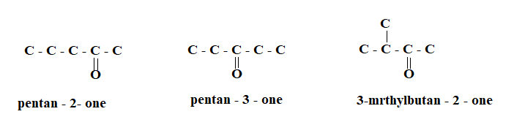
(can draw any 2, 1 mark for correct structure, 1 mark for correct naming)
(4 marks)
c. Polymerisation of Chloroethene can be represented by the following equation
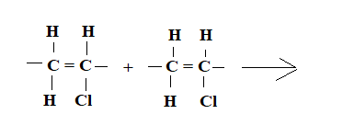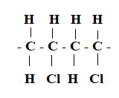
- Complete the equation above (1 mark)
- Name the type of polymerisation shown by the equation above
Additional polymerisation (1 mark)

- a. Mention any two salts that causes permanent water hardness
- Calcium sulphate (CaSO₄), Magnesium Sulphate (MgSO₄) (2 marks)
b. Describe any one role of the disaster risk management institutions in mitigating the effects of global warming in Malawi
- Sensitising people on how well the resources in the environment should be used 1, to avoid hazardous effects as emission of harmful gases into the atmosphere 1.
- Sensitising people 1, on the importance of the reafforestation 1.
- Giving financial assistance to small organisations 1 which are involved in environmental conservation management 1
- providing expertise to small organisations 1, which are involved in environmental conservation management 1 (any 2) (2 marks)
c. Differentiate between “recycling” and “reusing”
- recycling –changing a used item into a new product 1, while re using is the using of an item again for the same or a different purpose without changing/altering its form 1 (2 marks)

- Table 2 shows the results of an experiment on displacement reactions involving Copper (Cu), Magnesium (Mg), Zinc (Zn) and their aqueous solutions
Reaction | Observation
Cu_{(s)} + MgSO_{4 (aq)} | No reaction
Mg_{(s)} + CuSO_{4 (aq)} | Fast reaction
Zn_{(s)} + CuSO_{4 (aq)} | Slow reaction
Mg_{(s)} + ZnCl_{2(aq)} | Moderate reaction
Zn_{(s)} + MgSO_{4 (aq)} | No reaction

a. Write a balanced chemical equation for the reaction between magnesium and the solution of copper
Mg_{(s)} + CuSO₄ (aq) MgSO_{4(aq)} + Cu_{(s)}
I mark for correct reactants, 1 mark for correct products (2 marks)
b. Explain why a reaction does not occur between copper metal and magnesium sulphate solution
- magnesium metal is above copper metal in the reactivity series (1) hence copper metal cannot displace magnesium in its solution (1) (2 marks)
c. Explain how galvanisation prevents iron sheets from rusting.
- Galvanising involves coating of an iron sheet with zinc 1, when there is the presence of air and water (1), the zinc reacts with the air instead of iron sheets forming zinc oxide(1) hence the iron sheets are protected from rust (1) (4 marks)

- a. Explain how precipitation reactions are used in treating water containing phosphates
- - lime is added to the water(1) causing precipitations to occur (1), the precipitates are removed by filtration (1) (3 marks)
b. Describe how acidic oxides are formed
- Formed when non-metals react with oxygen (1), when the resultant oxide dissolves in water (1), it changes an indicator eg blue litmus paper to red (1) (3 marks)
- a. A certain carboxylic acid has 4 carbon atoms
- Determine its molecular formula
C_{n}H_{(2n+1)}COOH OR C_{n-1}H((_{2n-1) + 1)}COOH (1)
C₃H_{(2x3 +1)}COOH C₄₋₁H_{((2x4-1) + 1)}COOH
C₃H₇COOH C₃H₇COOH (1)
(2 marks)
- Name the carboxylic acid
Butanoic acid (1 mark)

b. Given below are different structures of butanol
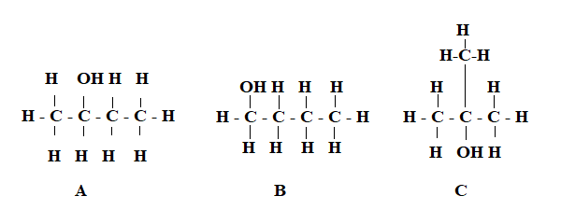
- Which structure represents a tertiary alcohol
C (1 mark)
- Explain your answer in 10b(i)
- The functional group/hydroxyl group/ -OH is attached/bonded (1) to a carbon atom that is bonded to three other carbon atoms (1) (2 marks)
- Name the product that will be formed when structure A undergoes oxidation
Butanone/ butan -2-one (1 mark)
- Give the name of the structure labelled C
2-methylpropan -2 -ol (1 mark)
SECTION B (30 marks)
Answer all the three questions in this section in the spaces provided
- a. Describe the effect of using Chlorofluorocarbons
- when chlorofluorocarbons goes into the atmosphere they react with ozone (1)
- they break the ozone into oxygen (1)
- this causes holes in the ozone layer (1)
- as such more harmful radiations reaches the earth’s surface (1)
- this causes skin cancer/eye cataracts/crop damage/global warming (1) (5 marks)
b. Describe how Calcium hydroxide can be used to remove temporary hardness from water. In your description include relevant chemical equations
- Calcium hydroxide is added to temporary hard water, this causes precipitation of magnesium and calcium ions (1)
Ca(HCO₃)₂(aq) + Ca(OH)_{2 (aq)} 2CaCO₃(s) + 2H₂O_{(l)}
1 mark 1 mark
Mg(HCO₃)₂(aq) + Ca(OH)_{2 (aq)} 2MgCO₃(s) + 2H₂O_{(l)}
1 mark 1 mark
(5 marks)
- Using a well labelled diagram, describe the electrolysis of dilute sodium iodide, in your description include relevant chemical equations.
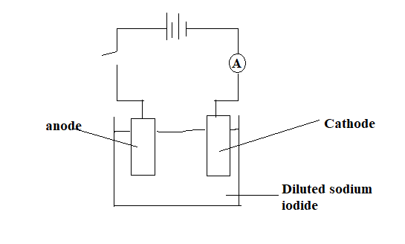

1 mark for correct diagram, 2 marks for any 3 correct labels

- When the switch is closed, current flows in the decomposing the electrolyte dilute sodium iodide (1)
- The ions present in the solution are Na⁺,I⁻, H⁺ and OH⁻ (1)
- The sodium ions and hydrogen ions are attracted to the cathode (1)where hydrogen ion is discharged because it is lower in the electrochemical series and gains electrons to become hydrogen gas (1)
$4H+ + 4e \overset{→}{ } {2H}_{2}$ (1)
- I⁻ and OH⁻ are attracted to the anode and the OH⁻ is discharge because it is more concentrated than I⁻ and loses electrons (1)
$4OH^{-} \overset{→}{ }O_{2} + 2H_{2}O +4e$ (1)
- Products formed include hydrogen gas, oxygen gas (1)(10 marks)
- a. Outline the steps you can use to prepare a solution using dilution method.
- calculate the volume of the standard solution to be diluted (1)
- measure the volume of the standard solution found from the calculation using a measuring cylinder (1)
- transfer the solution from the measuring cylinder into the required volumetric flask
- add distilled water up to the mark (1) (4 marks)
b. Describe how you can prepare nitric acid using potassium nitrate and concentrated sulphuric acid. (In your description include relevant chemical equations)
- put some potassium nitrate in a retort flask and add concentrated sulphuric acid (1)
- heat the mixture gently (1)
- run the tap water on the rounded bottomed flask (1)
- buble the air through the collected yellow liquid (1)
- collect the colourless liquid and keep it in dark bottles (1)
$H_{2}{SO}_{4} (aq) + KNO_{3} (aq) \overset{→}{ } HNO_{3} (aq) + K2SO4(aq)$ (1) (6 marks)

